Practical 9: CSS Grid and Reflection

Abdul Mejjallid
Department of I.T, Nova Scotia community College
DBAS1000: Website development
John MacDonald
October 31, 2025
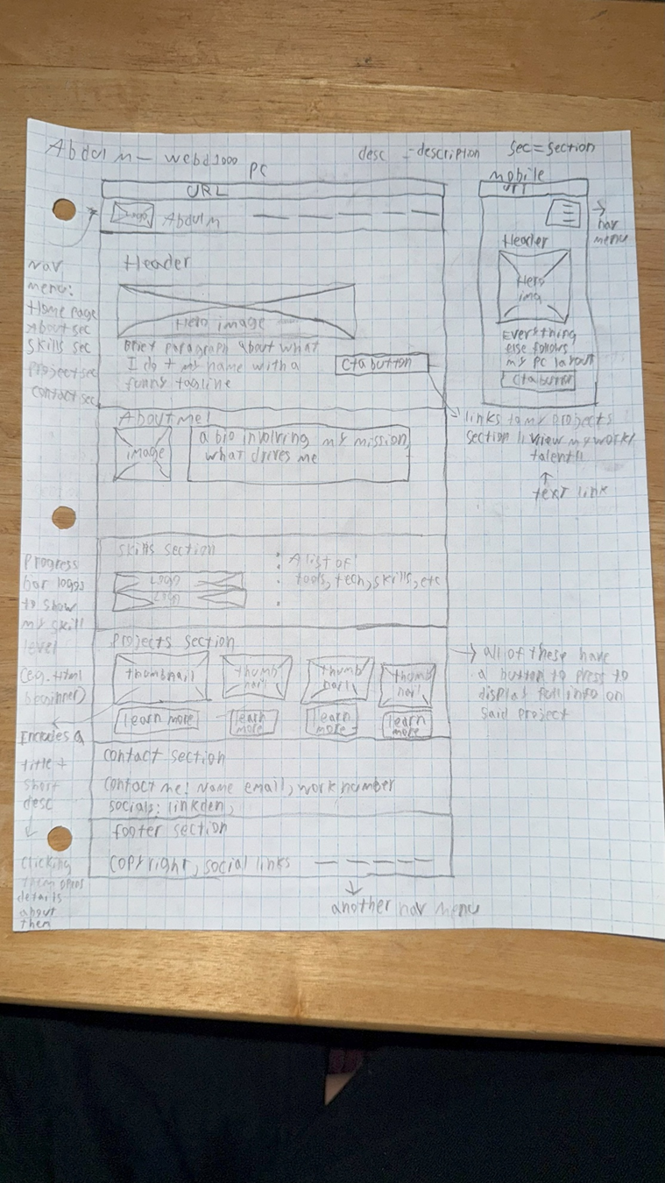
Figure 1 Wireframe

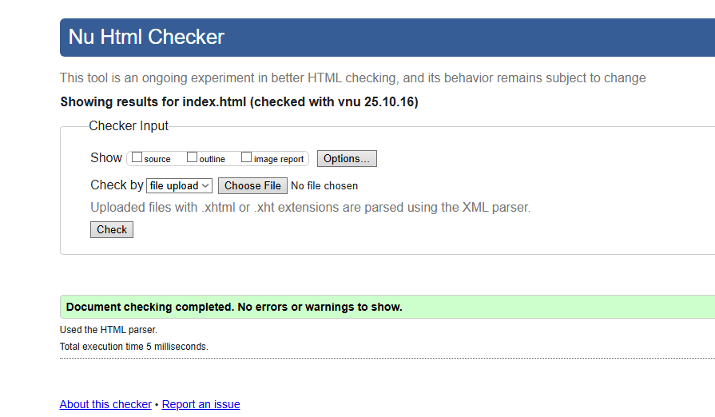
Figure 2 Index.html validation
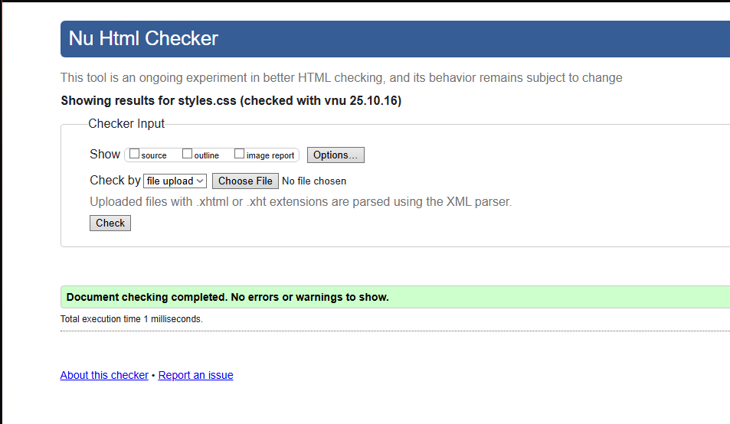
Figure 3 styles.css validation

Reflection.

The changes I have made were personal design choices I preferred over the original design of my wireframe. I opted to make my navigation section vertically instead of horizontally, as I felt it would make for a better mobile experience because it’s easier on the hand of the user. I also decided to place the logo above the bio in the about me section instead of side by side. As well as I scrapped the idea of the progress bars until a later date when I’m more advanced in said skills, so it looks better. In making these changes, I felt they looked much more professional and brought a cleaner, more professional aesthetic to my website that I like more.

Animation Section.
I added two animations to my website. the first one involves you hovering over the individual skill logos it shows my proficiency level at the top right of its container. the second animation is in hero section, I made the “More about me” button have a subtle pulse to catch the attention of people. I did this by making two separate keyframes one called “bounce” for my skills, and the other one called “pulse” which can be applied to any button.

COMMENTS RECEIVED
Comment from: | Comment | Accept/Reject | Rationale
Kyle P | Not enough personalization because there is still a lot of place holder text and ideas. | Accept | I agree with this criticism as I haven’t gone and put much effort into making the website my own for a lack of better words, I do intend on following up by editing the elements to the best of my ability to make it more personalized and fleshed out.
Tiernan G | Phone media needs to be resized to fit better on smaller screens as the skills section didn’t automatically adjust and a part of the projects section stuck out a bit | Accept | I agree with this as well as phone users would be satisfied with my website at all, I intend on tweaking the container that holds my skills and projects to make it fit better!
Zach F | Not enough colors the website makes it look like a machine made it and not a human with heart, and proper capitalization for professionalism | Accept | I half and half agree and disagree as I went for a more professional tone with the colours I might tweak them a bit for a better contrast, and I agree with the capitalization as it is important to show my level professionalism.

This page is for comments you have made to other students.
Comment made to: | Comment: | Rationale
Kyle P | I said that he could add a “target=”_blank”” for his skills so they open in a new tab, so users don’t close his website upon click. | I suggested these so users have a smoother experience on his website and I felt as users would just close out his website more often because of it.
Tiernan G | His “hire me” button” has a animation for colour which is cool but also a static colour that overwrites the animations so its kind of redundant. | I offered this comment because I felt as if it was redundant to have the static color override the cool animation when hovered upon.
Zach F | Some elements of his website were hidden if you didn’t know they exist like a website linked behind an image, and some fonts were hard to read as they were small | I said this because his effort would have just gone to waste as it wasn’t like a hidden easter egg thing, and more of a user’s should know this exists, and the font size on smaller screens was very hard making it not very user friendly.

